**Case 1: OLYMPICS**

Title Block

* **Project**: Olympics Athlete and Event Management System
* **Designer**: Ganesh Prasad Jaishi
* **Date**: 11/20/2023

**Synopsis**

The Olympics Athlete and Event Management System is designed to track and manage information related to athletes, the sports they participate in, the events within those sports, and the medals awarded. The system will serve the Olympic Committee to organize and retrieve athlete performance data efficiently.

**Business Analysis**

The system must offer a reliable way to associate athletes with their respective countries and the sports they compete in. It should allow for recording results of events, including medal winners. The database should be scalable to accommodate new sports, events, and participating athletes for future Olympic games.

**Business Rule:**

1. Each athlete competes in one sport.
2. Each sport has multiple events.
3. Each athlete will compete in at least one event within their sport.
4. A medal is awarded to the top 3 performers in each event: gold, silver and bronze.

**Assumptions:**

1. An athlete cannot represent more than one country.
2. An athlete does not switch sports during the Olympics.
3. The results of events and medal allocations are recorded immediately and accurately after the event concludes.
4. The database does not need to track any sponsorship or advertising information related to athletes or events.

**Conceptual Design:**

Entities: ATHLETE, COUNTRY, SPORT, EVENT, MEDAL

Attributes:

ATHLETE: ATHLETE_ID, FIRST_NAME, LAST_NAME, COUNTRY_ID, SPORT_ID

COUNTRY: COUNTRY_ID, COUNTRY_NAME

SPORT: SPORT_ID, SPORT_NAME

EVENT: EVENT_ID, SPORT_ID, EVENT_NAME

MEDAL: MEDAL_ID, EVENT_ID, ATHLETE_ID, MEDAL_TYPE

Entity Diagram:

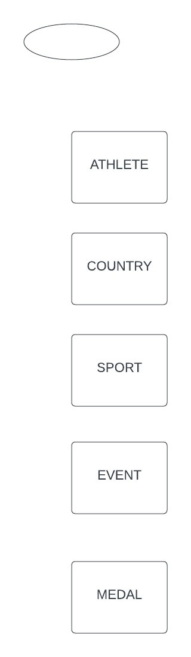

**Relationship Diagram:**

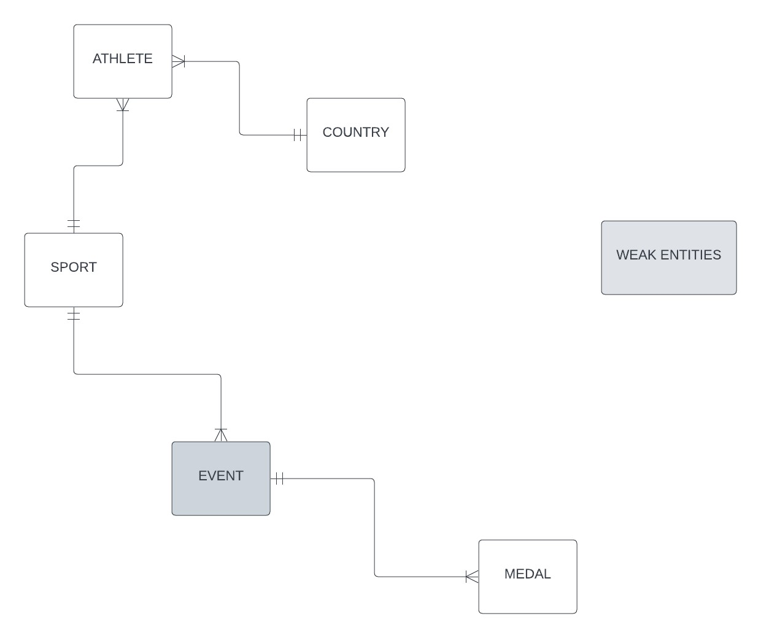

**EDR Diagram:**

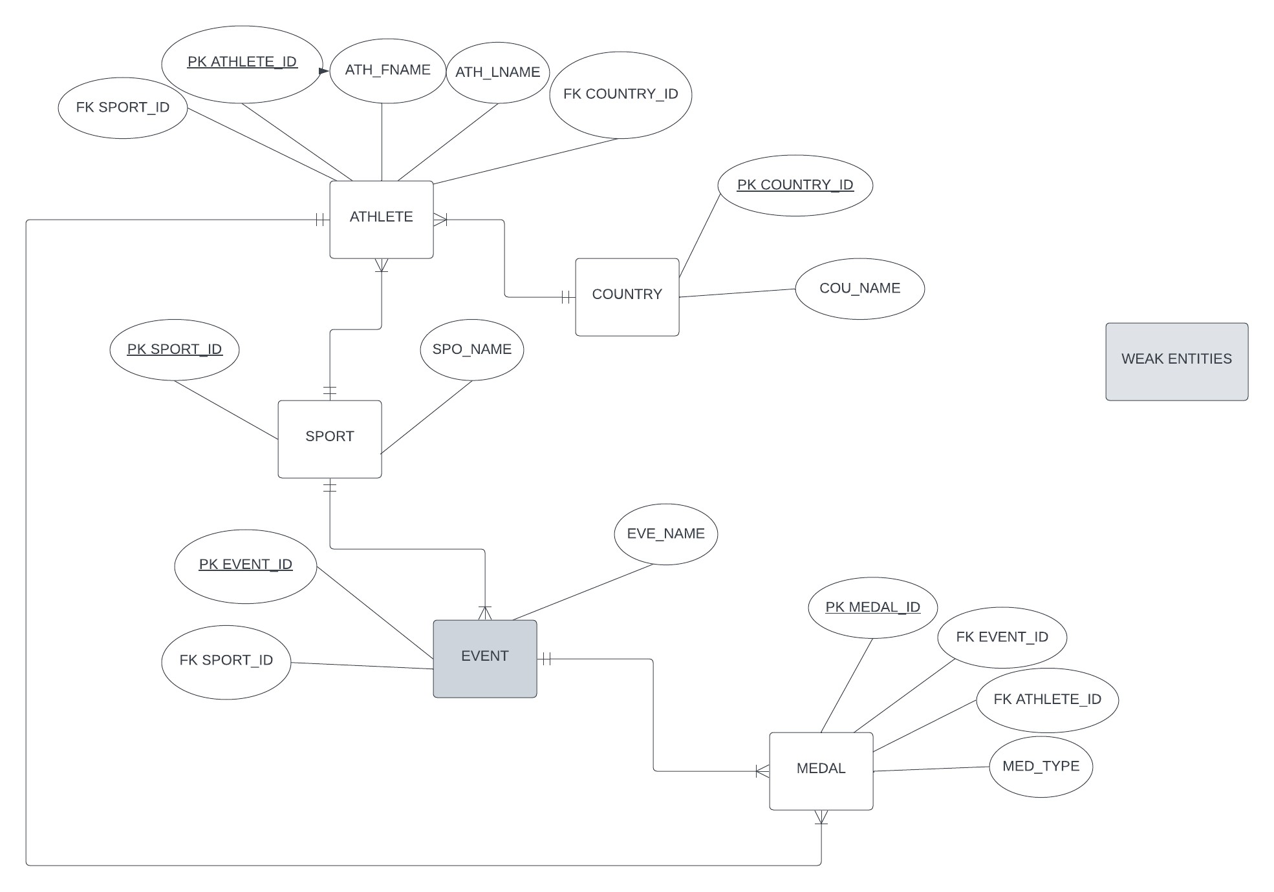

**Case 2: LIBRARY**

Title Block

* **Project**: NWTC Library Material Tracking System
* **Designer**: Ganesh Prasad Jaishi
* **Date**: 11/20/2023

**Synopsis**

The NWTC Library Material Tracking System aims to streamline the process of checking out various types of library materials to students and tracking the fines for late returns. The system will alleviate the administrative burden on library staff.

**Business Analysis**

The proposed database should manage the circulation of materials, including books, magazines, electronic media, and other resources. It should provide real-time information on which student has checked out which items and the due dates. Additionally, the system needs to calculate and track fines for late returns based on the type of material.

Business Rules

1. The library has many material types that can be checked out by students: books, magazines, electronic media, meeting rooms, and computers.
2. Each item is assigned to one material type.
3. A student can check out any number of materials, up to a maximum of 30 items at any given time.
4. A single item can only be checked out to one responsible student at a time.
5. Each material type has a different loan period. For example, a book can be checked out for 2 weeks, but a meeting room can only be checked out for 2-hour increments.
6. Items returned late will be charged a fine. The fine amount is dependent upon the material type the item is assigned to. For instance, a late book is fined 25 cents per day after the return date; a computer has a $10 per day fine after the return date.
7. Students are responsible for their library fines. Each student can only have a single total amount due balance.

Assumptions:

1. Students must have a library card to check out items.
2. Students will pay any fines incurred before checking out new items.
3. The library does not have a reservation system for materials that are currently checked out.
4. A specific item cannot be re-categorized into a different material type once it has been set.

Conceptual Design:

Entities: STUDENT, MATERIAL_TYPE, ITEM, LOAN, FINE

Attributes:

STUDENT: STUDENT_ID, FIRST_NAME, LAST_NAME, TOTAL_FINE

MATERIAL: MATERIAL_TYPE_ID, TYPE_NAME, LOAN_PERIOD, LATE_FEE

ITEM: ITEM_ID, MATERIAL_TYPE_ID, CHECKOUT_DATE, DUE_DATE, STUDENT_ID

LOAN: LOAN_ID, ITEM_ID, STUDENT_ID, LOAN_DATE, RETURN_DATE

FINE: FINE_ID, LOAN_ID, FINE_AMOUNT

**Entity Diagram:**

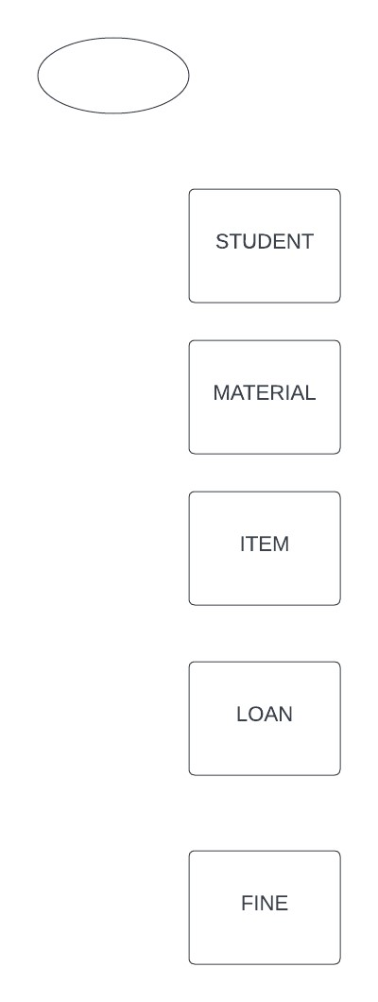

**Relationship Diagram:**

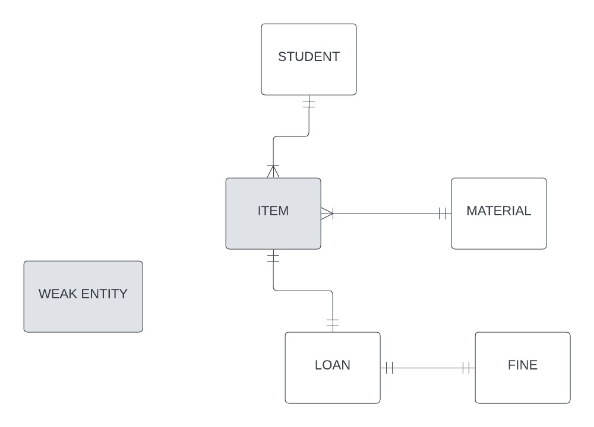

**EDR Diagram:**

